**AIM: To study different types of UI components and properties.**

**TITLE: Study of different types of UI components and properties.**

* **Theory:**
  + Different types of UI components are as follows:

1. Generally, in android the user interface of an app is made with a collection of View and View Group objects.
2. The View is a base class for all UI components in android and it is used to create interactive UI components such as Text View, Edit Text, Checkbox, Radio Button, etc. and it is responsible for event handling and drawing.
3. The View Group is a subclass of View and it will act as a base class for layouts and layout parameters. The View Group will provide invisible containers to hold other Views or View Groups and to define the layout properties.
   1. **Edit Text:**
      1. In android, Edit Text is a user interface control which is used to allow the user to enter or modify the text.
      2. While using Edit Text control in our android applications, we need to specify the type of data the text field can accept using the inputType attribute.
      3. For example, if it accept plain text, then we need to specify the inputType as “text”. In case if EditText field is for password, then we need to specify the inputType as “textPassword”.
      4. In android, EditText control is an extended version of TextView control with additional features and it is used to allow users to enter input values.
   2. **Text View:**
      1. In android, Text View is a user interface control that is used to set and display the text to the user based on our requirements.
      2. The Text View control will act as like label control and it won’t allow users to edit the text.
   3. **Radio Group:**
      1. In android, Radio Group is used to group one or more radio buttons into separate groups based on our requirements.
      2. If we group Radio Buttons using RadioGroup, at a time only one item can be selected from the group of radio buttons.
      3. In case, if we select one radio button that belongs to a radio group will unselect all other previously selected radio buttons within the same group.
   4. **Radio Button:**
      1. In android, Radio Button is a two states button that can be either checked or unchecked and it’s the same as CheckBox control, except that it will allow only one option to select from the group of options.
      2. The user can press or click on the radio button to make it select. In android, CheckBox control allow users to change the state of control either Checked or Unchecked but the radio button cannot be unchecked once it is checked.
      3. Generally, we can use RadioButton controls in an android application to allow users to select only one option from the set of values.
   5. **Check Box:**
      1. In android, CheckBox is a two states button that can be either checked (ON) or unchecked (OFF) and it will allow users to toggle between the two states (ON / OFF) based on the requirements.
      2. Generally, we can use multiple CheckBox controls in android application to allow users to select one or more options from the set of values.
   6. **Rating Bar:**
      1. In android, RatingBar is a UI control that is used to get the rating from the user.
      2. The RatingBar is an extension of SeekBar and ProgressBar that shows a rating in stars and it allows users to set the rating value by touch or click on the stars.
      3. The android RatingBar will always return a rating value as a floating-point number such as 1.0, 2.0, 2.5, 3.0, 3.5, etc.
   * Properties of button are as follows:
4. **setClickable():** 
   1. Enables or disables click events for this view. When a view is clickable it will change its state to "pressed" on every click. Subclasses should set the view clickable to visually react to user's clicks.
   2. Syntax:

public void setClickable (boolean clickable)

1. **setVisibility():**
   1. Set the visibility state of this view so user can see or not the component depending on value set.
   2. Syntax:

public void setVisibility (int visibility)

**A) Create an activity with all possible UI Components (Edit Text, Text view, Radio Button, Check Box, and Rating Bar). Get the values from the components and display it on the next activity.**

* **CODE:**
  + **activity_main.xml:**

<?xml version="1.0" encoding="utf-8"?>  
<ScrollView xmlns:android="http://schemas.android.com/apk/res/android"  
 xmlns:app="http://schemas.android.com/apk/res-auto"  
 xmlns:tools="http://schemas.android.com/tools"  
 android:layout_width="match_parent"  
 android:layout_height="match_parent"  
 android:background="#2596BE"  
 tools:context=".MainActivity">  
  
  
 <LinearLayout  
 android:layout_width="match_parent"  
 android:layout_height="wrap_content"  
 android:orientation="vertical">  
  
 <Space  
 android:layout_width="match_parent"  
 android:layout_height="32dp" />  
  
 <TextView  
 android:id="@+id/textView"  
 android:layout_width="match_parent"  
 android:layout_height="53dp"  
 android:text="REGISTRATION"  
 android:textAlignment="center"  
 android:textColor="@android:color/white"  
 android:textSize="30sp"  
 android:textStyle="bold" />  
  
 <Space  
 android:layout_width="match_parent"  
 android:layout_height="38dp" />  
  
 <EditText  
 android:id="@+id/name"  
 android:layout_width="match_parent"  
 android:layout_height="wrap_content"  
 android:backgroundTint="@android:color/white"  
 android:ems="10"  
 android:hint="Enter Name"  
 android:inputType="textPersonName"  
 android:minHeight="48dp"  
 android:textColor="@color/white" />  
  
 <Space  
 android:layout_width="match_parent"  
 android:layout_height="22dp" />  
  
 <EditText  
 android:id="@+id/roll"  
 android:layout_width="match_parent"  
 android:layout_height="wrap_content"  
 android:backgroundTint="@color/white"  
 android:ems="10"  
 android:hint="Enter Roll No"  
 android:inputType="number"  
 android:minHeight="48dp"  
 android:textColor="@android:color/white" />  
  
 <Space  
 android:layout_width="match_parent"  
 android:layout_height="22dp" />  
  
 <EditText  
 android:id="@+id/dept"  
 android:layout_width="match_parent"  
 android:layout_height="wrap_content"  
 android:backgroundTint="@android:color/white"  
 android:ems="10"  
 android:hint="Enter Department"  
 android:inputType="textPersonName"  
 android:minHeight="48dp"  
 android:textColor="@android:color/white" />  
  
 <Space  
 android:layout_width="match_parent"  
 android:layout_height="22dp" />  
  
 <TextView  
 android:id="@+id/textView2"  
 android:layout_width="match_parent"  
 android:layout_height="29dp"  
 android:minHeight="48dp"  
 android:text="Select Shift:"  
 android:textColor="@android:color/white"  
 android:textSize="18sp" />  
  
 <RadioGroup  
 android:layout_width="155dp"  
 android:layout_height="wrap_content"  
 android:id="@+id/radiogrp">  
  
 <RadioButton  
 android:id="@+id/ra1"  
 android:layout_width="match_parent"  
 android:layout_height="wrap_content"  
 android:text="Morning"  
 android:textColor="@android:color/white"  
 android:textSize="16sp" />  
  
 <RadioButton  
 android:id="@+id/ra2"  
 android:layout_width="match_parent"  
 android:layout_height="wrap_content"  
 android:text="Afternoon"  
 android:textColor="@android:color/white"  
 android:textSize="16sp" />  
 </RadioGroup>  
  
 <Space  
 android:layout_width="match_parent"  
 android:layout_height="22dp" />  
  
 <TextView  
 android:id="@+id/textView3"  
 android:layout_width="match_parent"  
 android:layout_height="27dp"  
 android:minHeight="48dp"  
 android:text="Select Hobbies:"  
 android:textColor="@android:color/white"  
 android:textSize="18sp" />  
  
 <CheckBox  
 android:id="@+id/dan"  
 android:layout_width="128dp"  
 android:layout_height="wrap_content"  
 android:text="Dance"  
 android:textColor="@android:color/white" />  
  
 <CheckBox  
 android:id="@+id/sin"  
 android:layout_width="128dp"  
 android:layout_height="wrap_content"  
 android:text="Sing"  
 android:textColor="@android:color/white" />  
  
 <CheckBox  
 android:id="@+id/pla"  
 android:layout_width="128dp"  
 android:layout_height="wrap_content"  
 android:text="Play"  
 android:textColor="@android:color/white" />  
  
 <Space  
 android:layout_width="match_parent"  
 android:layout_height="22dp" />  
  
 <TextView  
 android:id="@+id/textView4"  
 android:layout_width="match_parent"  
 android:layout_height="29dp"  
 android:minHeight="48dp"  
 android:text="Rate Me:"  
 android:textColor="@android:color/white"  
 android:textSize="18sp" />  
  
 <RatingBar  
 android:id="@+id/ratingBar"  
 android:layout_width="wrap_content"  
 android:layout_height="wrap_content" />  
  
 <Space  
 android:layout_width="match_parent"  
 android:layout_height="35dp" />  
  
 <Button  
 android:id="@+id/reg"  
 android:layout_width="355dp"  
 android:layout_height="59dp"  
 android:backgroundTint="@android:color/white"  
 android:insetLeft="60dp"  
 android:onClick="onClick"  
 android:text="Register"  
 android:textColor="#2596BE"  
 android:textSize="18sp"  
 android:textStyle="bold"  
 tools:ignore="OnClick" />  
  
 <Space  
 android:layout_width="match_parent"  
 android:layout_height="35dp" />  
  
 </LinearLayout>  
</ScrollView>

* + **activity_display_data.xml:**

<?xml version="1.0" encoding="utf-8"?>  
  
  
<ScrollView xmlns:android="http://schemas.android.com/apk/res/android"  
 xmlns:tools="http://schemas.android.com/tools"  
 android:layout_width="match_parent"  
 android:layout_height="match_parent"  
 android:background="#2596BE"  
 tools:ignore="SpeakableTextPresentCheck">  
  
 <LinearLayout  
 android:layout_width="match_parent"  
 android:layout_height="wrap_content"  
 android:orientation="vertical">  
  
 <Space  
 android:layout_width="match_parent"  
 android:layout_height="37dp" />  
  
 <TextView  
 android:id="@+id/textView5"  
 android:layout_width="match_parent"  
 android:layout_height="wrap_content"  
 android:text="REGISTRATION SUCCESS"  
 android:textAlignment="center"  
 android:textColor="@android:color/white"  
 android:textSize="30sp"  
 android:textStyle="bold" />  
  
 <Space  
 android:layout_width="match_parent"  
 android:layout_height="58dp" />  
  
 <TextView  
 android:id="@+id/t1"  
 android:layout_width="match_parent"  
 android:layout_height="31dp"  
 android:minHeight="48dp"  
 android:textAlignment="center"  
 android:textColor="@android:color/white"  
 android:textSize="25sp"  
 android:textStyle="bold" />  
  
 <Space  
 android:layout_width="match_parent"  
 android:layout_height="37dp" />  
  
 <TextView  
 android:id="@+id/t2"  
 android:layout_width="match_parent"  
 android:layout_height="31dp"  
 android:minHeight="48dp"  
 android:textAlignment="center"  
 android:textColor="@android:color/white"  
 android:textSize="25sp"  
 android:textStyle="bold" />  
  
 <Space  
 android:layout_width="match_parent"  
 android:layout_height="37dp" />  
  
 <TextView  
 android:id="@+id/t3"  
 android:layout_width="match_parent"  
 android:layout_height="31dp"  
 android:minHeight="48dp"  
 android:textAlignment="center"  
 android:textColor="@android:color/white"  
 android:textSize="25sp"  
 android:textStyle="bold" />  
  
 <Space  
 android:layout_width="match_parent"  
 android:layout_height="37dp" />  
  
 <TextView  
 android:id="@+id/t4"  
 android:layout_width="match_parent"  
 android:layout_height="31dp"  
 android:minHeight="48dp"  
 android:textAlignment="center"  
 android:textColor="@android:color/white"  
 android:textSize="25sp"  
 android:textStyle="bold" />  
  
 <Space  
 android:layout_width="match_parent"  
 android:layout_height="37dp" />  
  
 <TextView  
 android:id="@+id/t9"  
 android:layout_width="match_parent"  
 android:layout_height="31dp"  
 android:minHeight="48dp"  
 android:text="Hobbies:"  
 android:scrollbars = "vertical"  
 android:textAlignment="center"  
 android:textColor="@android:color/white"  
 android:textSize="25sp"  
 android:textStyle="bold" />  
  
 <TextView  
 android:id="@+id/t5"  
 android:layout_width="match_parent"  
 android:layout_height="wrap_content"  
 android:minHeight="48dp"  
 android:scrollbarAlwaysDrawVerticalTrack="true"  
 android:textAlignment="center"  
 android:textColor="@android:color/white"  
 android:textSize="25sp"  
 android:textStyle="bold" />  
  
 <Space  
 android:layout_width="match_parent"  
 android:layout_height="37dp" />  
  
 <TextView  
 android:id="@+id/t6"  
 android:layout_width="match_parent"  
 android:layout_height="31dp"  
 android:minHeight="48dp"  
 android:textAlignment="center"  
 android:textColor="@android:color/white"  
 android:textSize="25sp"  
 android:textStyle="bold" />  
  
 </LinearLayout>  
</ScrollView>

* + **MainActivity.java:**

package com.example.practical3_a;  
  
import androidx.appcompat.app.AppCompatActivity;  
  
import android.content.Intent;  
import android.os.Bundle;  
import android.view.View;  
import android.widget.Button;  
import android.widget.CheckBox;  
import android.widget.EditText;  
import android.widget.RadioButton;  
import android.widget.RadioGroup;  
import android.widget.RatingBar;  
import android.widget.TextView;  
  
import java.util.ArrayList;  
  
public class MainActivity extends AppCompatActivity {  
Button send_button;  
RatingBar ratingBar;  
RadioGroup rg1;  
RadioButton rb1,rb2;  
CheckBox c1,c2,c3;  
EditText object1,object2,object3;  
String shift;  
ArrayList<String> hobby = new ArrayList<>();  
  
 @Override  
 protected void onCreate(Bundle savedInstanceState) {  
 super.onCreate(savedInstanceState);  
 setContentView(R.layout.*activity_main*);  
 send_button = findViewById(R.id.*reg*);  
 object1 = findViewById(R.id.*name*);  
 object2 = findViewById(R.id.*roll*);  
 object3 = findViewById(R.id.*dept*);  
 ratingBar = findViewById(R.id.*ratingBar*);  
 rg1 = findViewById(R.id.*radiogrp*);  
 c1 = findViewById(R.id.*dan*);  
 c2 = findViewById(R.id.*sin*);  
 c3 = findViewById(R.id.*pla*);  
  
 send_button.setOnClickListener(new View.OnClickListener() {  
 public void onClick(View v) {  
 String name = object1.getText().toString();  
 String roll = object2.getText().toString();  
 String dept = object3.getText().toString();  
 String rate = String.*valueOf*(ratingBar.getRating());  
 rb1 = findViewById(R.id.*ra1*);  
 rb2 = findViewById(R.id.*ra2*);  
 if (rb1.isChecked()) {  
 shift = "Morning";  
 }  
 if (rb2.isChecked()) {  
 shift = "Afternoon";  
 }  
 if (c1.isChecked()) {  
 hobby.add(c1.getText().toString());  
 }  
 if (c2.isChecked()) {  
 hobby.add((String) c2.getText());  
 }  
 if (c3.isChecked()) {  
 hobby.add((String) c3.getText());  
 }  
  
 Intent intent = new Intent(getApplicationContext(), DisplayData.class);  
 intent.putExtra("nam", name);  
 intent.putExtra("roll", roll);  
 intent.putExtra("dept", dept);  
 intent.putExtra("rat", rate);  
 intent.putExtra("shi", shift);  
 intent.putExtra("hob", hobby);  
 startActivity(intent);  
  
 }  
 } ); }}

* + **DisplayData.java:**

package com.example.practical3_a;  
  
import androidx.appcompat.app.AppCompatActivity;  
  
import android.content.Intent;  
import android.os.Bundle;  
import android.text.method.ScrollingMovementMethod;  
import android.widget.ArrayAdapter;  
import android.widget.ListView;  
import android.widget.TextView;  
  
import java.util.ArrayList;  
  
public class DisplayData extends AppCompatActivity {  
TextView tv1,tv2,tv3,tv4,tv6,tv5;  
 @Override  
 protected void onCreate(Bundle savedInstanceState) {  
 super.onCreate(savedInstanceState);  
 setContentView(R.layout.*activity_display_data*);  
 tv1=findViewById(R.id.*t1*);  
 tv2=findViewById(R.id.*t2*);  
 tv3=findViewById(R.id.*t3*);  
 tv4=findViewById(R.id.*t4*);  
 tv5=findViewById(R.id.*t5*);  
 tv6=findViewById(R.id.*t6*);  
 Intent intent = getIntent();  
  
 String str1 = intent.getStringExtra("nam");  
 tv1.setText("Name: "+str1);  
  
 String str2 = intent.getStringExtra("roll");  
 tv2.setText("Roll No: "+str2);  
  
 String str3 = intent.getStringExtra("dept");  
 tv3.setText("Department: "+str3);  
  
 String str4 = intent.getStringExtra("shi");  
 tv4.setText("Shift: "+str4);  
  
 ArrayList<String> myList = (ArrayList<String>) getIntent().getSerializableExtra("hob");  
 tv5.setText("");  
  
 for (int j = 0; j < myList.size(); j++){  
 tv5.append( myList.get(j) + "\n");  
 }  
 tv5.setMovementMethod(new ScrollingMovementMethod());  
  
   
  
  
 String str5 = intent.getStringExtra("rat");  
 tv6.setText("Rating: "+str5);  
  
  
  
 }  
}

* **OUTPUT:** 
  + **GUI After Filling Data**

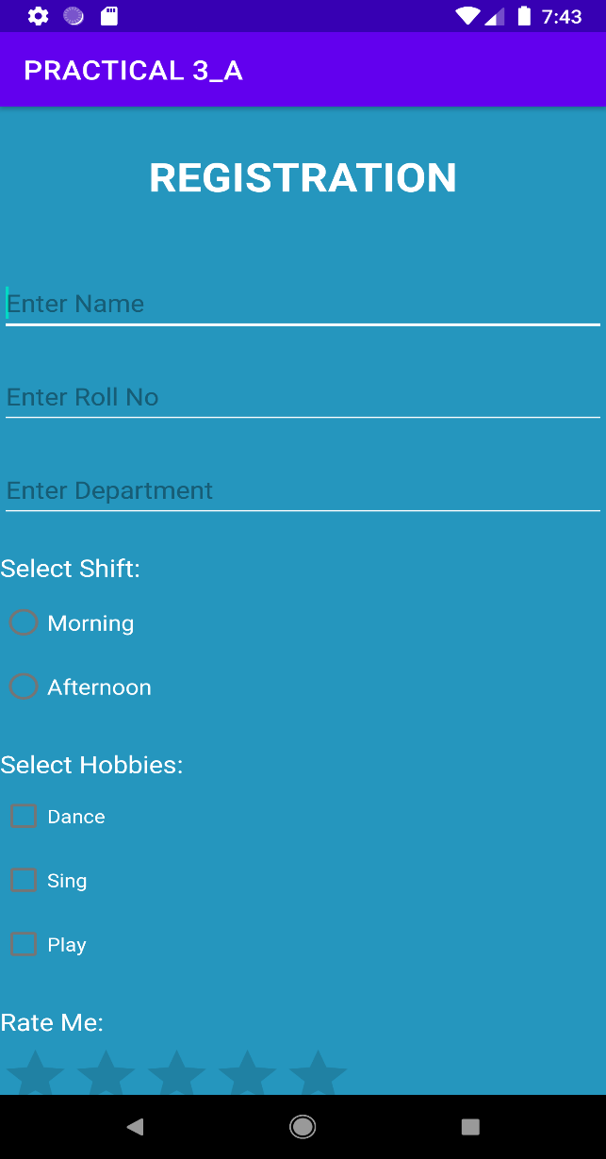 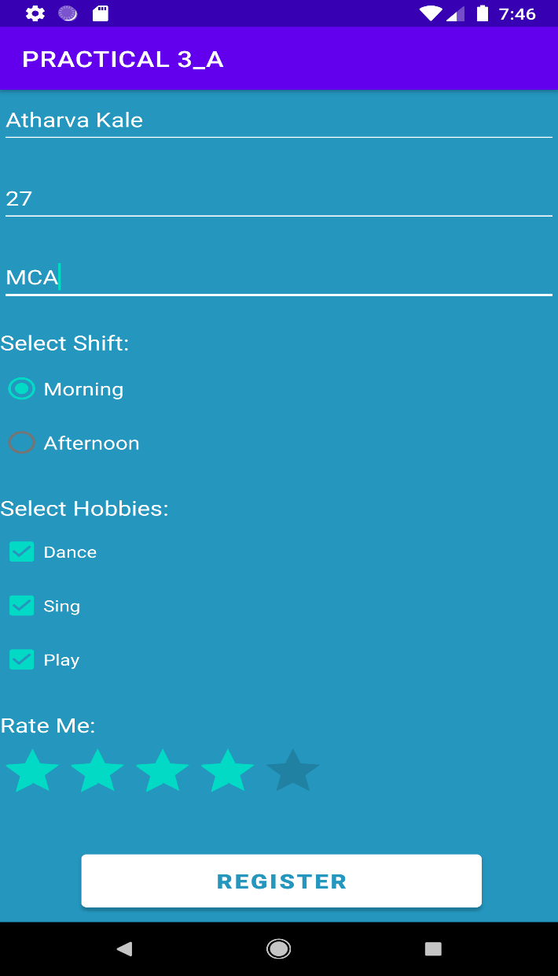

* **Display Data:**

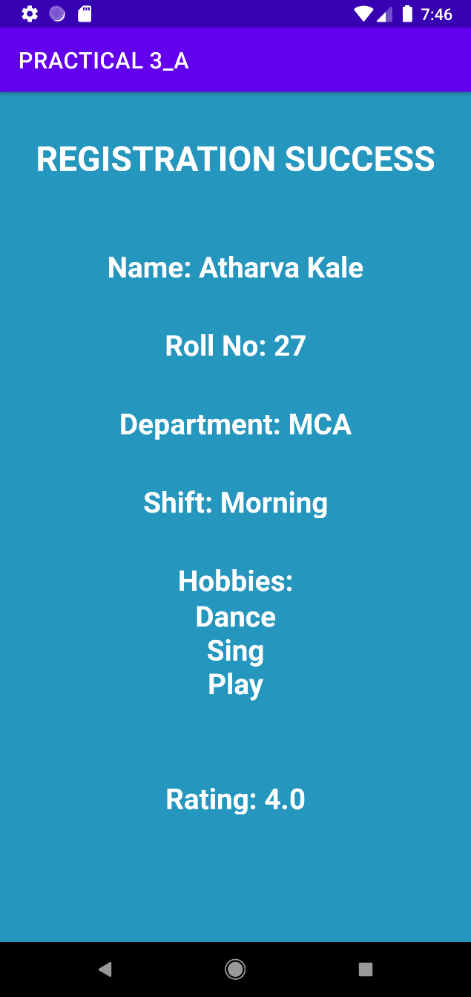

**B) Create a login form. For successful login, display welcome page and in case of failure display alert box indicating error message and attempts made. Disable submit button after 3 wrong attempts and display the alert message indicating the same.**

* **CODE:**
  + **activity_main.xml:**

<?xml version="1.0" encoding="utf-8"?>  
<androidx.constraintlayout.widget.ConstraintLayout xmlns:android="http://schemas.android.com/apk/res/android"  
 xmlns:app="http://schemas.android.com/apk/res-auto"  
 xmlns:tools="http://schemas.android.com/tools"  
 android:layout_width="match_parent"  
 android:layout_height="match_parent"  
 tools:context=".MainActivity">  
  
 <TextView  
 android:id="@+id/textView"  
 android:layout_width="182dp"  
 android:layout_height="49dp"  
 android:text="LOGIN"  
 android:textAlignment="center"  
 android:textSize="30sp"  
 android:textStyle="bold"  
 app:layout_constraintBottom_toBottomOf="parent"  
 app:layout_constraintEnd_toEndOf="parent"  
 app:layout_constraintHorizontal_bias="0.497"  
 app:layout_constraintStart_toStartOf="parent"  
 app:layout_constraintTop_toTopOf="parent"  
 app:layout_constraintVertical_bias="0.043" />  
  
 <EditText  
 android:id="@+id/user"  
 android:layout_width="wrap_content"  
 android:layout_height="wrap_content"  
 android:ems="10"  
 android:hint="Enter Username"  
 android:inputType="textPersonName"  
 app:layout_constraintBottom_toBottomOf="parent"  
 app:layout_constraintEnd_toEndOf="parent"  
 app:layout_constraintHorizontal_bias="0.497"  
 app:layout_constraintStart_toStartOf="parent"  
 app:layout_constraintTop_toTopOf="parent"  
 app:layout_constraintVertical_bias="0.243"  
 tools:ignore="MissingConstraints" />  
  
 <EditText  
 android:id="@+id/pass"  
 android:layout_width="wrap_content"  
 android:layout_height="wrap_content"  
 android:ems="10"  
 android:hint="Enter Password"  
 android:inputType="textPassword"  
 app:layout_constraintBottom_toBottomOf="parent"  
 app:layout_constraintEnd_toEndOf="parent"  
 app:layout_constraintHorizontal_bias="0.497"  
 app:layout_constraintStart_toStartOf="parent"  
 app:layout_constraintTop_toTopOf="parent"  
 app:layout_constraintVertical_bias="0.392"  
 tools:ignore="MissingConstraints" />  
  
 <Button  
 android:id="@+id/log"  
 android:layout_width="106dp"  
 android:layout_height="52dp"  
 android:onClick="onClick"  
 android:text="LOGIN"  
 app:layout_constraintBottom_toBottomOf="parent"  
 app:layout_constraintEnd_toEndOf="parent"  
 app:layout_constraintHorizontal_bias="0.498"  
 app:layout_constraintStart_toStartOf="parent"  
 app:layout_constraintTop_toTopOf="parent"  
 app:layout_constraintVertical_bias="0.555"  
 tools:ignore="MissingConstraints,OnClick" />  
</androidx.constraintlayout.widget.ConstraintLayout>

* + **activity_welcome_page.xml:**

<?xml version="1.0" encoding="utf-8"?>  
<androidx.constraintlayout.widget.ConstraintLayout xmlns:android="http://schemas.android.com/apk/res/android"  
 xmlns:app="http://schemas.android.com/apk/res-auto"  
 xmlns:tools="http://schemas.android.com/tools"  
 android:layout_width="match_parent"  
 android:layout_height="match_parent"  
 tools:context=".WelcomePage">  
  
 <TextView  
 android:id="@+id/textView2"  
 android:layout_width="359dp"  
 android:layout_height="96dp"  
 android:textAlignment="center"  
 android:textSize="30sp"  
 android:textStyle="bold"  
 tools:layout_editor_absoluteX="40dp"  
 tools:layout_editor_absoluteY="347dp"  
 tools:ignore="MissingConstraints" />  
</androidx.constraintlayout.widget.ConstraintLayout>

* + **MainActivity.java:**

package com.example.practical3_b;  
  
import androidx.appcompat.app.AppCompatActivity;  
  
import android.content.Intent;  
import android.os.Bundle;  
import android.view.View;  
import android.widget.Button;  
import android.widget.EditText;  
import android.widget.Toast;  
  
public class MainActivity extends AppCompatActivity {  
 int count=0;  
 EditText u,p;  
 Button b;  
 View bu;  
 @Override  
 protected void onCreate(Bundle savedInstanceState) {  
 super.onCreate(savedInstanceState);  
 setContentView(R.layout.*activity_main*);  
 u=findViewById(R.id.*user*);  
 p=findViewById(R.id.*pass*);  
 b=findViewById(R.id.*log*);  
 bu = findViewById(R.id.*log*);  
  
 }  
  
 public void onClick(View view) {  
 String us = u.getText().toString();  
 String pa = p.getText().toString();  
 if (count<2)  
 {  
 if(us.equals("Atharva") && pa.equals("Kale"))  
 {  
 Toast.*makeText*(MainActivity.this, "LOGIN SUCCESS", Toast.*LENGTH_SHORT*).show();  
 Intent intent = new Intent(getApplicationContext(), WelcomePage.class);  
 intent.putExtra("nam", u.getText().toString());  
 startActivity(intent);  
 }  
 else  
 {  
 count+=1;  
 Toast.*makeText*(MainActivity.this, "LOGIN FAILED!!", Toast.*LENGTH_SHORT*).show();  
 Toast.*makeText*(MainActivity.this, "Remaining Attempts: "+(3-count), Toast.*LENGTH_SHORT*).show();  
 }  
 }  
 else  
 {  
 b.setClickable(false);  
 bu.setVisibility(View.*GONE*);  
 Toast.*makeText*(MainActivity.this, "LOGIN FAILED!! TRY AGAIN AFTER SOME TIME!!", Toast.*LENGTH_SHORT*).show();  
 }  
  
  
 }  
}

* + **WelcomePage.java:**

package com.example.practical3_b;  
  
import androidx.appcompat.app.AppCompatActivity;  
  
import android.content.Intent;  
import android.os.Bundle;  
import android.widget.TextView;  
  
public class WelcomePage extends AppCompatActivity {  
  
 @Override  
 protected void onCreate(Bundle savedInstanceState) {  
 super.onCreate(savedInstanceState);  
 setContentView(R.layout.*activity_welcome_page*);  
 TextView t1 = (TextView) findViewById(R.id.textView2);  
 Intent intent = getIntent();  
  
 String str1 = intent.getStringExtra("nam");  
 t1.setText("Welcome "+str1);  
 }  
}

* **OUTPUT:**
  + **Correct Username and Password:**

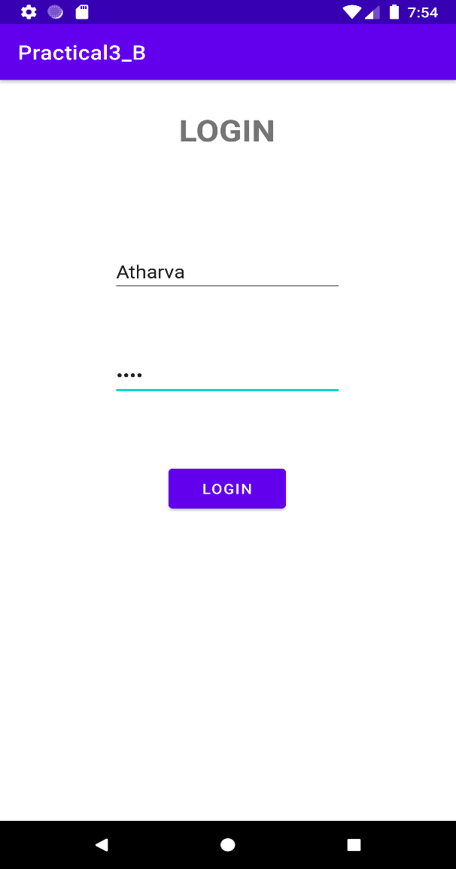 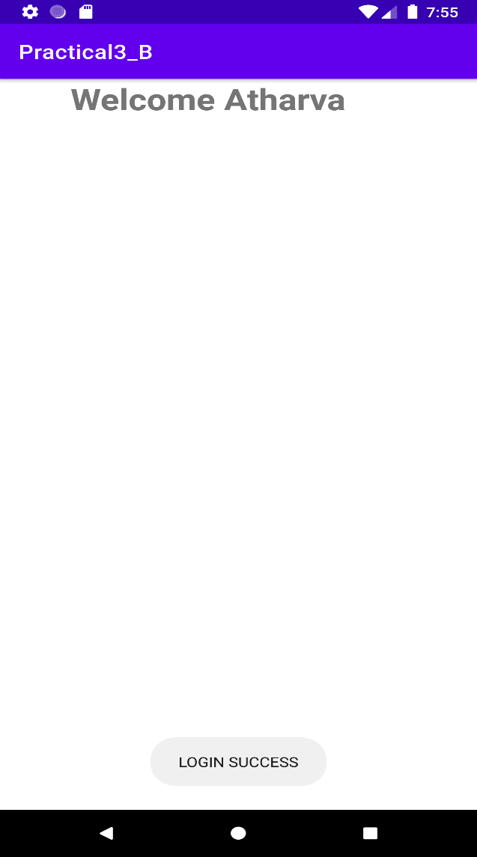

* + **Failed Attempts and Button Disabled:**

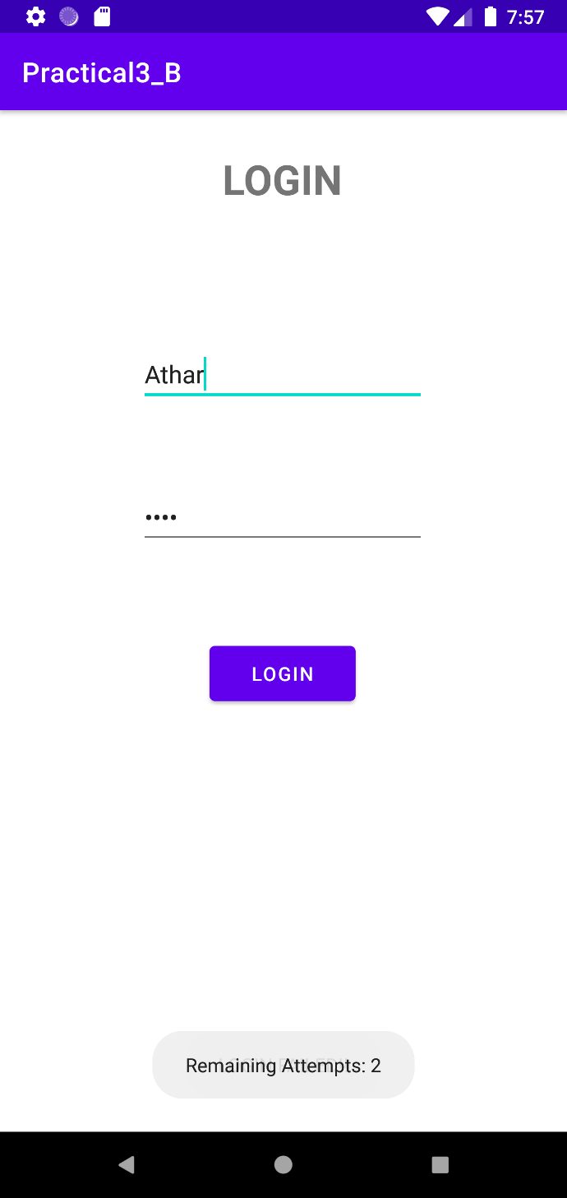 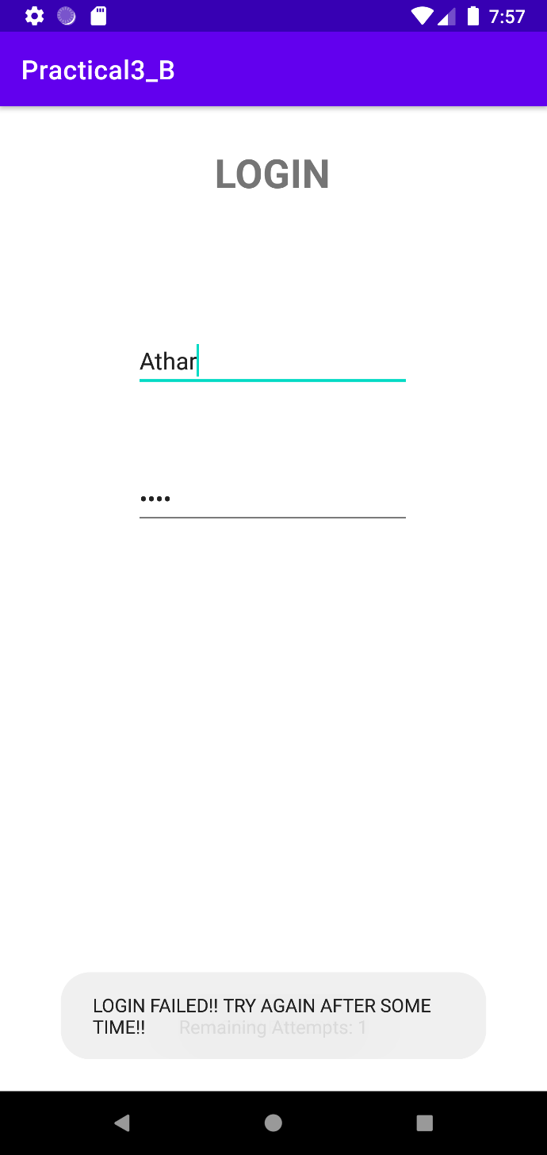

* **Conclusion:**

Hence we successfully studied different types of UI components and properties.